Republic of the Philippines
Department of Education
Region X
Division of Iligan City

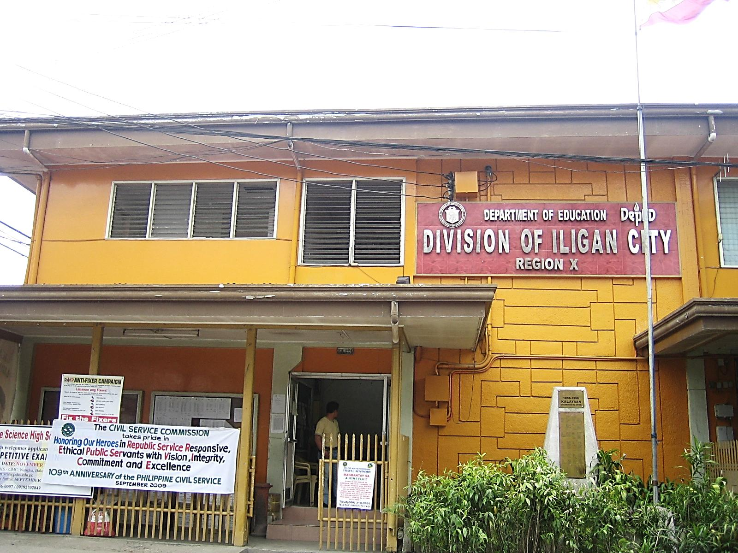
SY: 2013 - 2014
ILIGAN CITY DIVISION

Citizen’s Charter

2014 Compilation

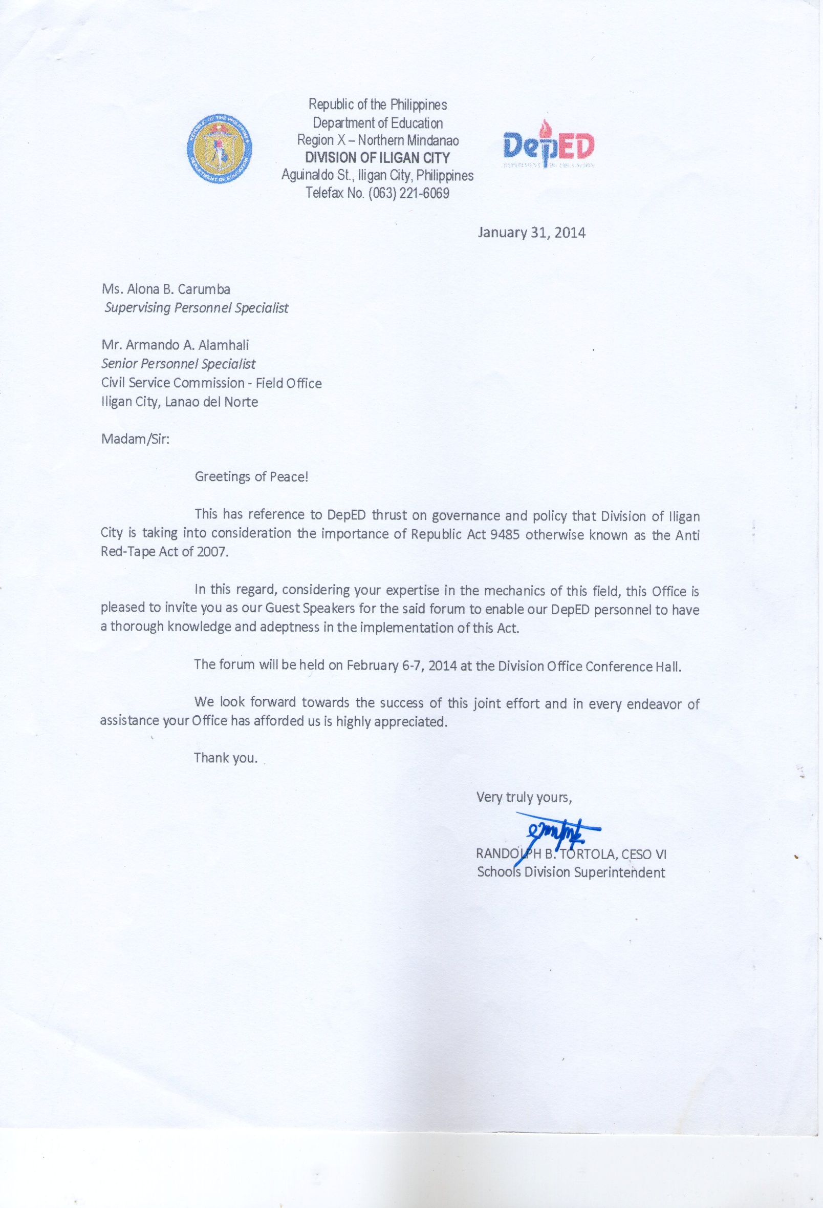
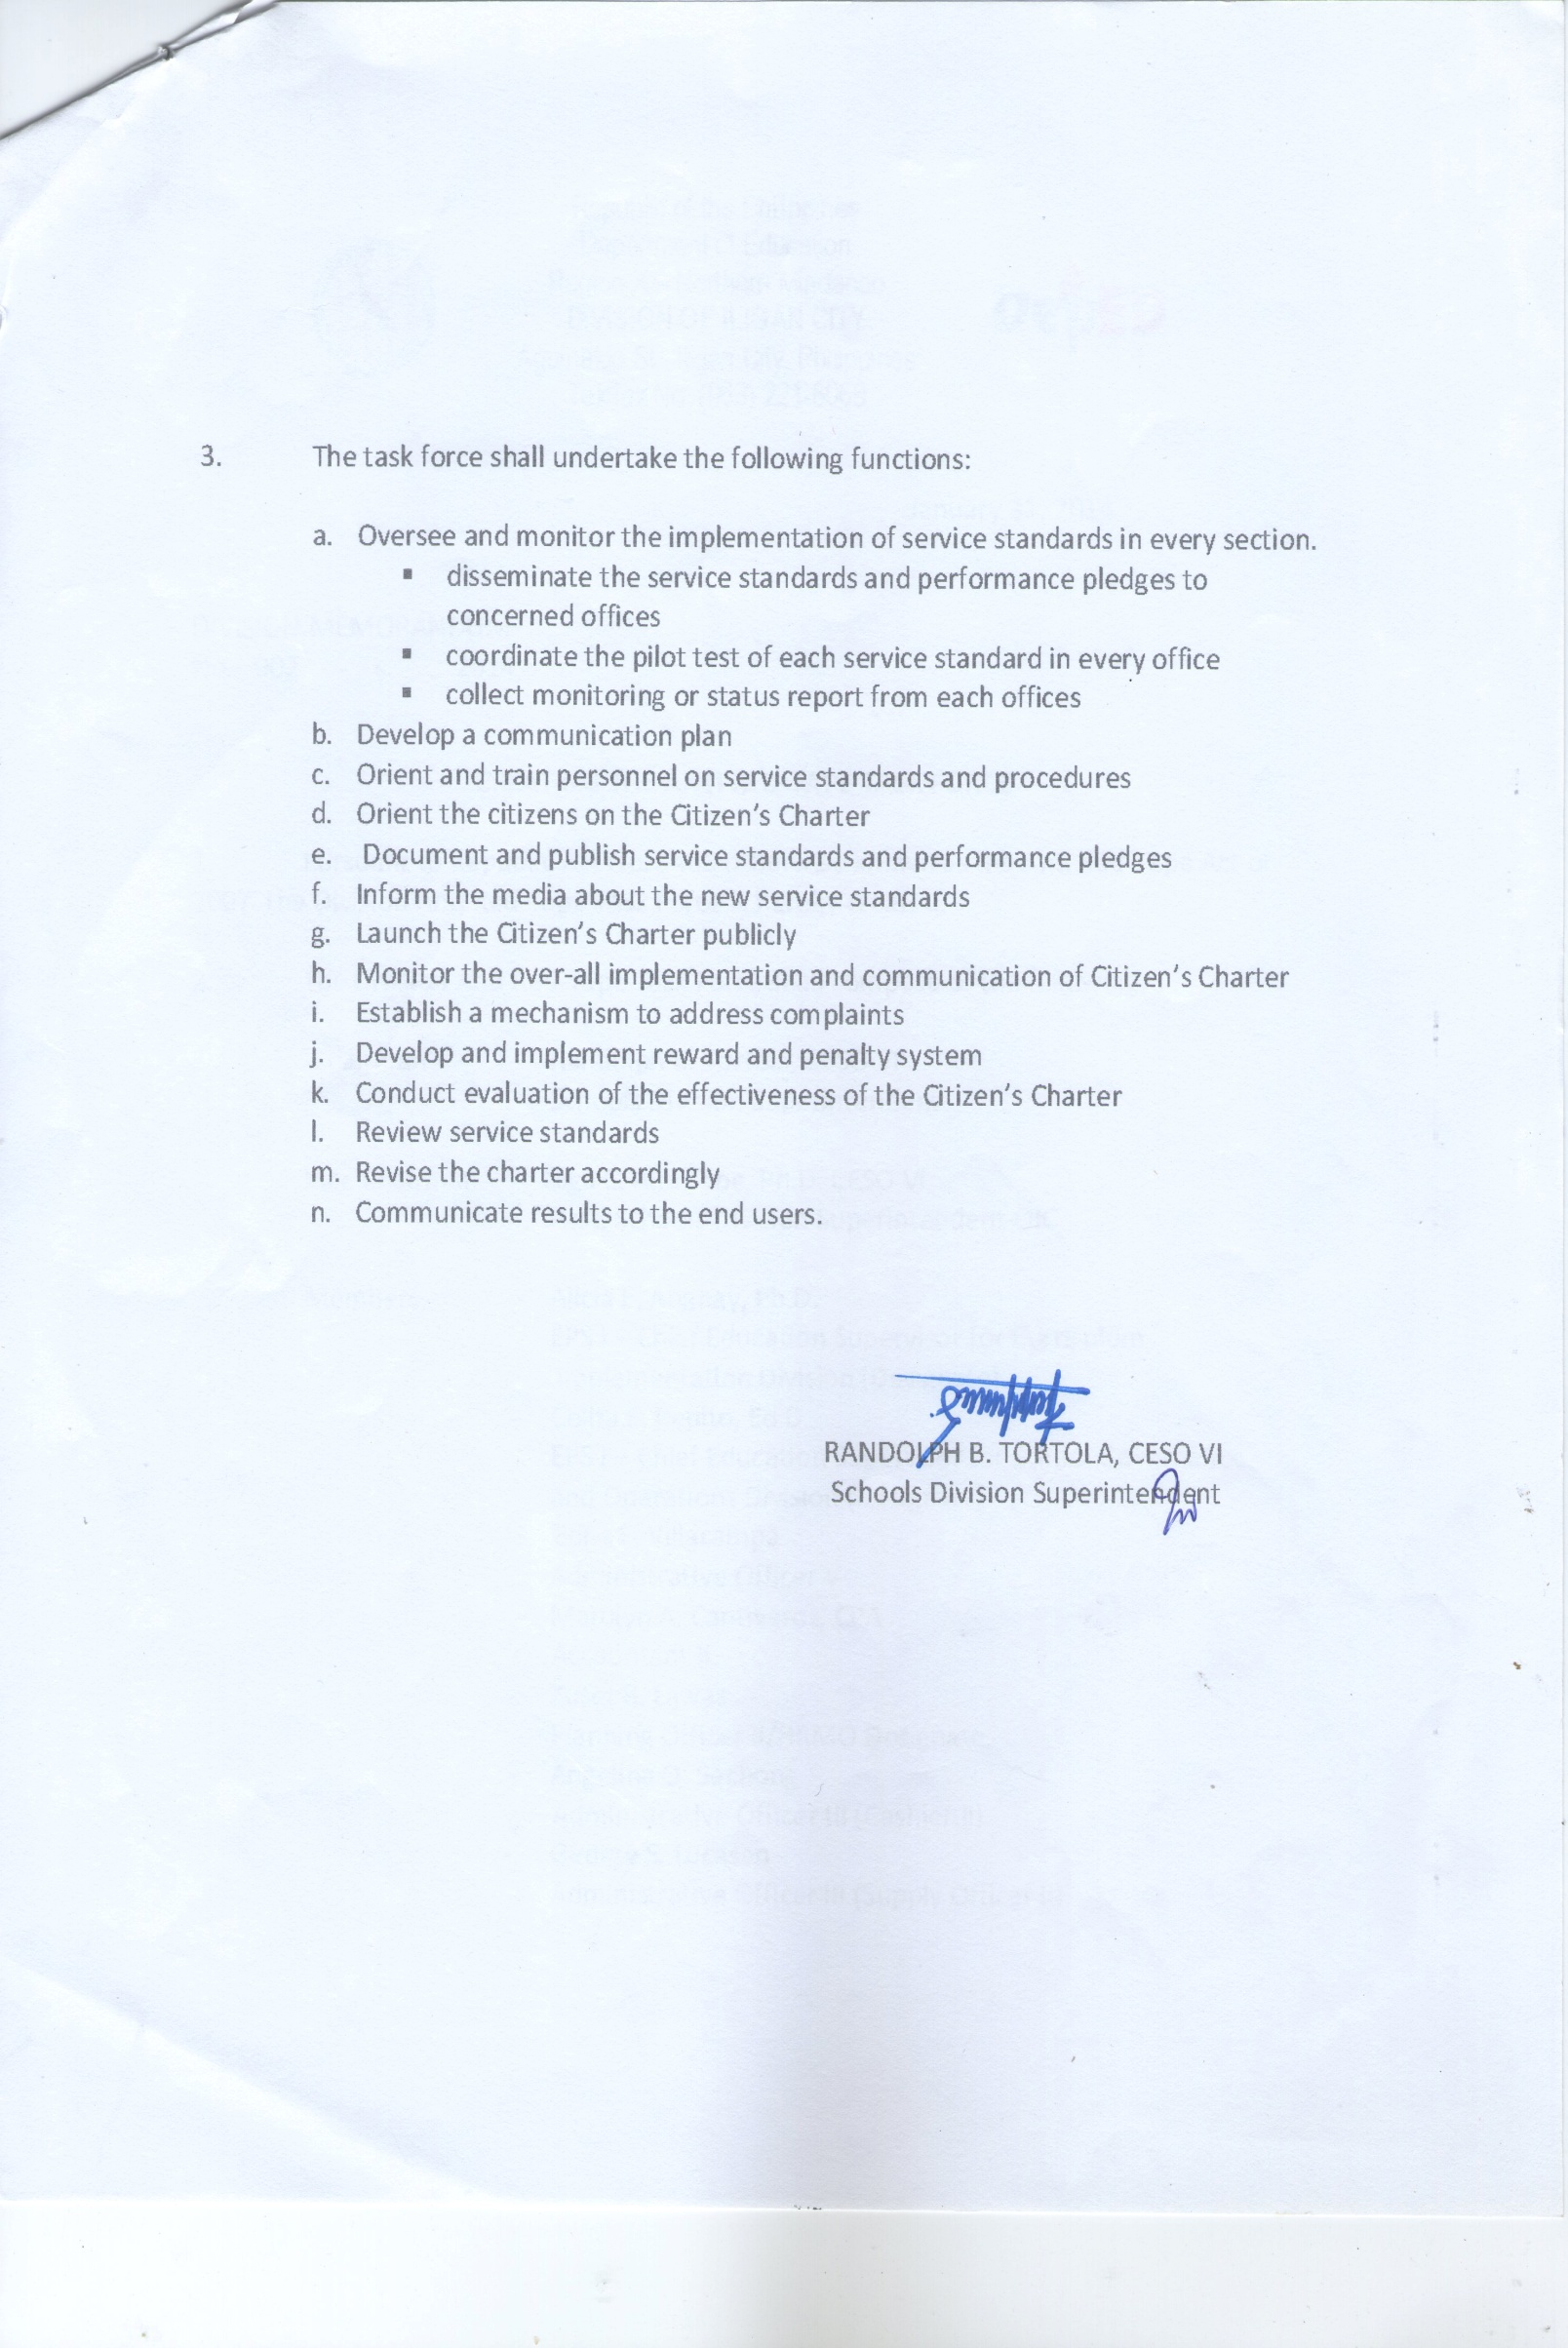
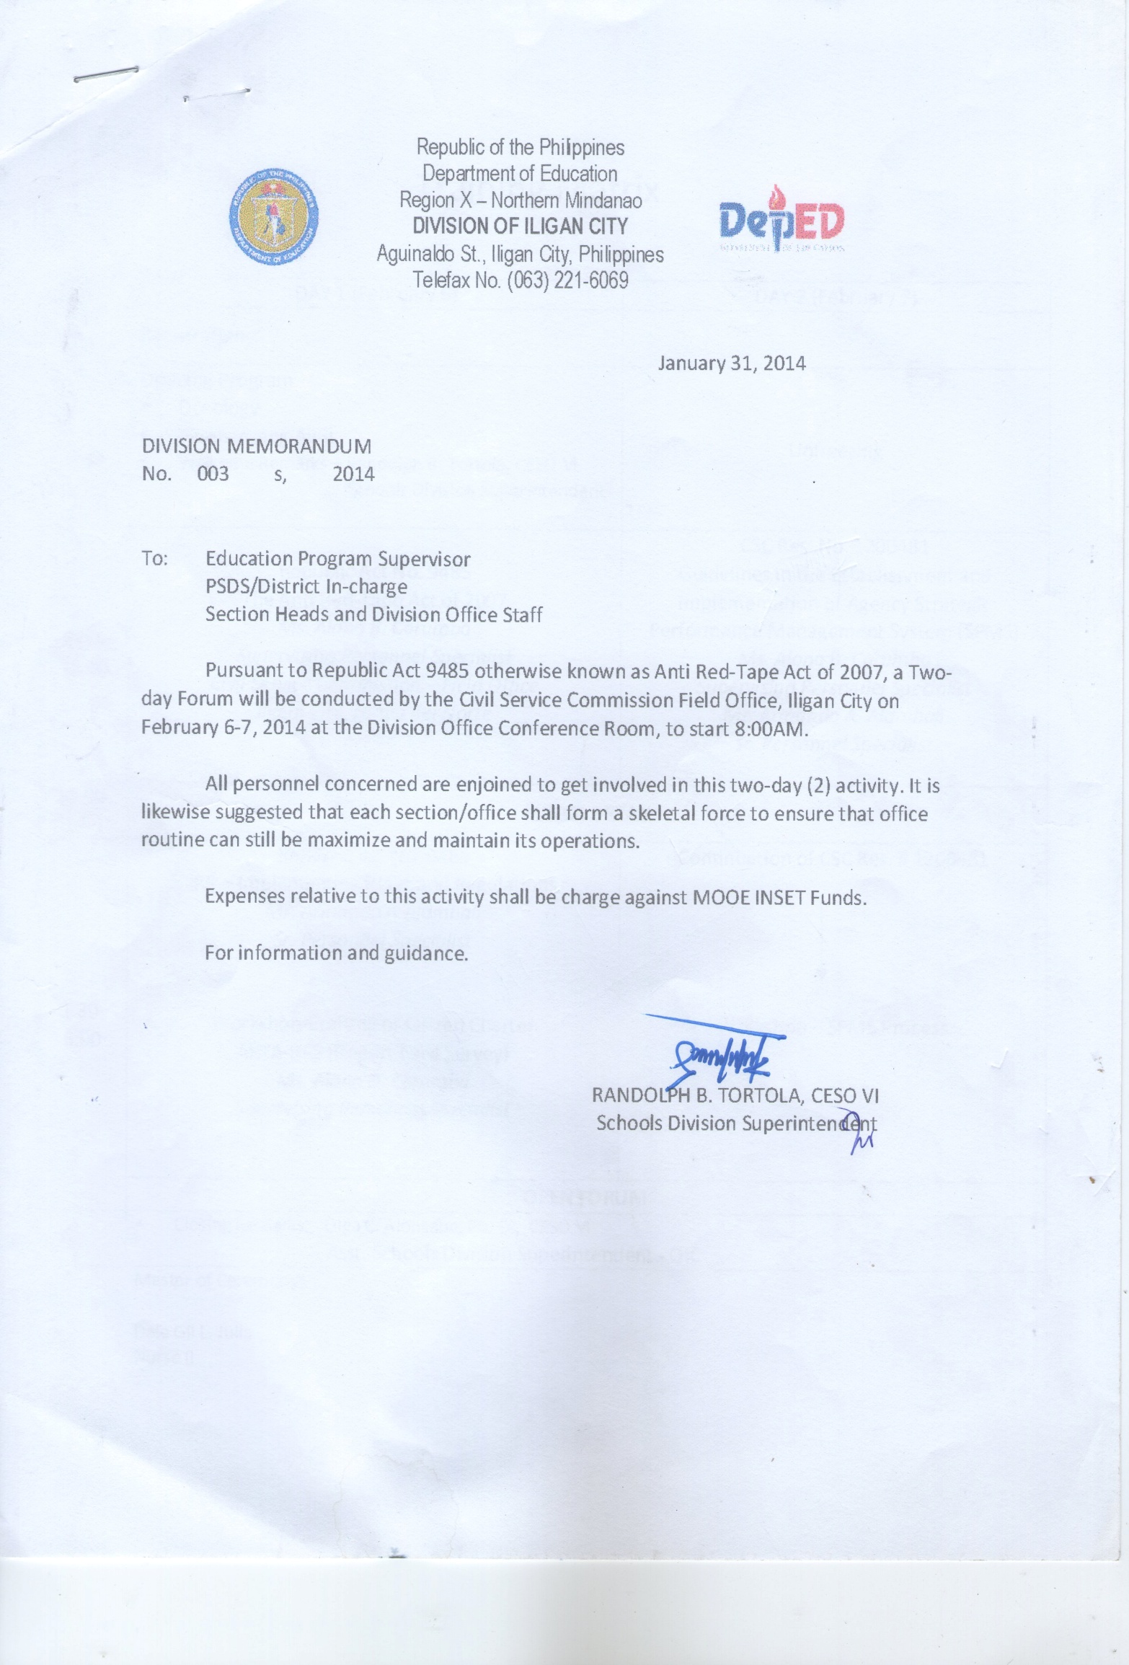

DEPARTMENT OF EDUCATION
DIVISION OFFICE ORGANIZATIONAL CHART
DIVISION OF ILIGAN CITY
OFFICE OF THE SCHOOLS DIVISION SUPERINTENDENT

LGU
CSC
------------------------------------------------------------------------------------------------------------
COA
NGO
------------------------------------------------------------------------------------------------------------
OFFICE OF THE ASST. SCHOOLS DIVISION SUPERINTENDENT

ADMIN UNIT
PROMOTIONAL UNIT
PLANNING UNIT
HEALTH & NUTRITION UNIT

SCHOOL
ACCOUNTINGG
PERSONNEL

SEC.
RECORDS
CASHIERING
ELEM.
ALTERNATIVE LEARNING SYSTEM (ALS)

SUPPLY
GEN. SERVICES
PSDS
COORDINATORS
SEC. SCHOOL ADMINSTRATORS

SEC. SCHOOL TEACHERS
ELEM. SCHOOL ADMINSTRATORS
MOBILE TEACHERS INSTRUCTIONAL MANAGERS

ELEM. SCHOOL TEACHERS

LEARNERS
STUDENTS
LEGEND:
_____ DIRECT LINE OF SUPERVISION
-------- LINE OF COORDINATION

Division Directory
Introduction

A critical component of DepED Iligan City Division’s program of governance is the promotion of transparency and accountability at all levels of its organization. Its initiatives to improve the efficiency of transactions have resulted in the formulation of a Citizen’s Charter which will serve as a guide to avoid unnecessary delays in the delivery of services.

The Charter contains a detailed procedure for citizens needing to avail of its frontline services. It also introduces a step-by-step process for new and more effective approaches on administrative regulations such as hastening the application for and processing of public documents.

Intending to weed out the amount and complexity of government formalities and paperwork, the Division has shifted to a formative brand of service which places public interests above its own personal and local pursuits.

Hence, the DepED Iligan City Division Citizen’s Charter on R.A. 9485 otherwise known as “The Anti-Red Tape Act” is hereby presented.

The DepEd Vision

We dream of Filipinos
who passionately love their country
and whose competencies and values
enable them to realize their potential
and contribute meaningfully to building the nation
As a learner-centered public institution,
the Department of Education
continuously improves itself
to better serve its stakeholders.

The DepEd Mission

To protect and promote the right of every Filipino to quality, equitable, culture-based, and complete basic education where:

- Students learn a child-friendly, gender-sensitive, safe and motivating environment;

- Teachers facilitate learning and constantly nurture every learner;

- Administrators and staff, as stewards of the institution, ensure an enabling and supportive environment for effective learning to happen;

- Family, community, and other stakeholders are actively engaged and share responsibility for developing life-long learners.

Our Core Values

- Maka-Diyos
- Makakalikasan
- Makatao
- Makabansa

Performance Pledge

We, the officials and employees of the Department of Education, Division of Iligan City, commit to:

- Serve the clientele promptly, effectively and efficiently with utmost courtesy from Mondays to Fridays from 8:00 AM – 12:00 NOON and 1:00 PM – 5:00 PM;

- Ensure strict compliance with service standards to avoid delays in frontline services;

- Respond to your complaint about our services the soonest or within tolerable time through our public assistant desk;

- Value every clientele’s comments, suggestions, and needs; and

- Empower the public 40 hours in a week access to information on the Division’s programs, policies, projects and other services through the following Telephone Numbers:

SDS Office 221 - 6069
ASDS Office 223 - 2780
Promotional Staff 223 - 0525
Private School’s Unit 223 - 3090
ALS Unit 223 - 8251
Administrative Officer V Office 223 - 2271
Medical/Dental Section 223 - 3134
Accounting Section 223 - 2720
Personnel Section 223 - 0526
Cashier’s Section 223 - 5591
Planning Unit 225 - 4315
Supply Section 225 - 4316
Records Section 221 - 3815
Feedback and Redress Mechanism

Please inform us on how we have catered your needs by doing the following:

- Accomplish our Feedback Form available in any of the Sections/Units mentioned and drop it at the Mamayan Muna Hindi Mamaya Na drop box located at the Officer of the Day Desk

- Talk to our Officer of the Day

- Dial the Telephone Number stated where you present your feedback

Note: If you are not satisfied with our services, your written/verbal feedback shall be immediately attended to by the Officer of the Day at the Public Assistance and Complaints Desk

THANK YOU

SERVICE STANDARDS BASED ON RA 9485

- No application/request to be returned to the client without appropriate action (approval or disapproval)

- Action should not be longer than 5 working days for simple transactions and 10 working days for complex transactions

- Signatories in any document limited up to five (5)

- Staff must wear official identification card when transacting with public

LIST OF FRONTLINE SERVICES
List of Frontline Services

STEPS ON HOW TO AVAIL OF THE FRONTLINE SERVICES
ALTERNATIVE LEARNING SYSTEM SECTION

Frontline Service: Processing of Appointments

Schedule of Availability of Service: Monday-Friday 8:00 AM – 5:00 PM NO NOON BREAK

Who may avail of the services: Instructional Managers, Literacy Facilitators, and District ALS Coordinators

What are the Requirements: Accomplished Appointment Papers, Learning Group Record (LGR), Name of Report,
IM’s Personal Data Sheet, Time Schedule, Training Module for LST

Duration: 14 minutes

How to avail of the service:
Step | Applicant/Client | Service Provider | Duration of Activity Under Normal Circumstances | Person In Charge | Fees | Form
1  2 | Submit accomplished appointment papers and supporting documents  Receive approved appointment | - Receive papers & documents and log the received documents  - Check the appointment papers and supporting documents  - Return due to lack of supporting documents or incorrect data  - Recommend approval of the appointment to SDS  - Submit the appointment papers & supporting documents to SDS for approval  - Inform Clients of the approved appointments ready for release  - Release Appointment | 1 minute  10 minutes  1 minute  1 minute  1 minute | ALS Clerk  Div ALS  Coordinator  EPS I-ALS  ALS Clerk  ALS Clerk | None  None | Appointment  LGR  Name of Report  IM PDS  Time Schedule  Training Matrix (for LST classes)  -do-
END OF TRANSACTION

Frontline Service: Submission of Accomplished Forms / Reports

Schedule of availability of service: Monday to Friday 8:00 AM-5:00 PM ‘NO NOON BREAK’

Who May Avail of the Services: District ALS Coordinators, Mobile Teachers and ALS Facilitators with Contracts

What are the Requirements: Duly signed reports by the Principals / PSDS

Duration: 12 minutes

How to avail of the service:
Step | Applicant/Client | Service Provider | Duration of Activity Under Normal Circumstances | Person In Charge | Fees | Form
1  2 | Submit duly signed reports by the Principals /PSDS  Receive the signed reports by the EPS I-ALS | - Receive the reports and log at the logbook  - Check reports  - Return reports due to lack of signatures and/or incorrect data  - Finalize the reports and ready for Consolidation  - Signed the report  - Release the duly signed reports by the EPS I-ALS | 1 minute  5 minutes  5 minutes  1 minute  1 minute | ALS Clerk  Div ALS Coordinator  EPS I-ALS  ALS Clerk | NONE  NONE | *LGR;  *Accomplishment Reports  *Session Program  *Quarterly Report  *MIS Forms
END OF TRANSACTION

Frontline Service: Processing of A&E Test Registration

Schedule of availability of the services: May-July, Monday to Friday, 8:00 AM- 5:00 PM “NO NOON BREAK”

Who may avail of the services: OSY, OSA and Over Aged In-School (Qualified A&E Test Takers)

What are the requirements: Birth Certificate, latest 2x2 ID picture (with name tag and IC Division Region X),
Accomplished Registration Form

Duration: 8 minutes

How to avail of the service:

Step | Applicant/Client | Service Provider | Duration of Activity Under Normal Circumstances | Person In Charge | Fees | Form
1  2 | Accomplish and Submit A&E Test Registration Forms  Receives the admission slip | - Assist Registrants in Filling Up Registration Forms  - Check Authenticated Birth Certificate  - Release the admission slip | 5 minutes  2 minutes  1 minute | Test Registration Officer (TRO)  TRO | None  None | Registration Form  Admission Slip
END OF TRANSACTION

CITIZENS CHARTER
Planning Unit

Frontline Service : Validation of Statistical Forms and Templates

Schedule of Availability of Service : Monday-Friday 8:00AM – 5:00 PM NO NOON BREAK)
Who May Avail of the services : School Heads, Teachers (In-charge of Encoding Statistical Forms & Templates)
What are the requirements : Accomplished School Forms
Duration : 30 minutes (School Forms)
30 minutes (LIS Online)

How to avail of the service:
Step | Applicant/Client | Service Provider | PROCESSING TIME  (Under normal circumstances per transaction) | FEES | PERSON IN-CHARGE | FORM
1  2 | Submit accomplished statistical forms  for validation  Request for LIS validation | Review and validate forms and online encoding of data if properly accomplished by the School Heads/EBEIS Coordinators  Validate encoded LIS prepared by the School Heads/Teachers (EBEIS Coordinators) | 30 minutes  30 minutes | NONE  NONE | Planning Unit Staff  Planning Unit Staff | EBEIS Profile  School Forms  School Forms
END OF TRANSACTION

Frontline Service : Request for statistical data and other related information

Schedule of Availability of Service : Monday-Friday 8:00AM – 5:00 PM NO NOON BREAK)
Who May Avail of the services : Researchers, LGU, NGOs, Students and Private Institutions
What are the requirements : Letter-request address to the Schools Division Superintendent
Duration : 10 minutes

How to avail of the service:

Step | Applicant/Client | Service Provider | PROCESSING TIME  (Under normal circumstances per transaction) | FEES | PERSON IN-CHARGE | FORM
1 | Submit letter of intent address to the Schools Division Superintendent indicating purpose for the request of data | Receive the letter-request from the office of the SDS  - Process complete data according to its specific details  - Validate the data if encoded  accurately  - Present the final output to the SDS for approval and signature | 10 minutes | None | Planning Unit Staff | Letter-request
END OF TRANSACTION

Frontline Service : Request for CAV Indorsement

Schedule of Availability of Service : Monday-Friday 8:00AM – 5:00 PM NO NOON BREAK)
Who May Avail of the services : OFWs, Applying for Employment Abroad and Former Students
What are the requirements : School Diploma, Form 137A/E and School Certification.
Duration : 15 minutes
How to avail of the service:

Step | Applicant/Client | Service Provider | PROCESSING TIME  (Under normal circumstances per transaction) | FEES | PERSON IN-CHARGE | FORM
1 | Submit complete  school credentials applying for CAV indorsement to the Regional Office | Receive the school credentials as to the authenticity of the documents presented.  Verify the completeness and veracity of the documents ( if documents presented are in order)  Process CAV Indorsement  Indorsement presented to the SDS for signature (it depends on the availability of the signatory) | 15 minutes | None  None  None  None | Grace Y. Ganob | - School  Diploma  - Form  137A/E  - School  Certification
END OF TRANSACTION

Frontline Service : Inspection of procured office supplies delivered by the suppliers

Schedule of Availability of Service : Monday-Friday 8:00AM – 5:00 PM NO NOON BREAK)
Who May Avail of the services : Suppliers, Purchase Orders of End-user
What are the requirements : Inspection & Acceptance Report (IAR), Purchase Orders, Official Receipts.
Duration : 10 minutes
How to avail of the service:

Step | Applicant/Client | Service Provider | PROCESSING TIME  (Under normal circumstances per transaction) | FEES | PERSON IN-CHARGE | FORM
1 | Deliver procured  office supplies  Review of items or office supplies ready for  inspection | Verify procured office supplies as to quantity and specifications if found in order.  Actual itemize Inspection of the delivered office supplies according to purchase order presented.  Inspected the items with signature affixed by the Inspectorate Team. Items/office supplies are all set for distribution to the end-users thru the Supply Office. | 3 minutes  5 minutes  2 minutes | None  None  None | Zuset B. Lawas/  Grace Y. Ganob | IAR  Purchase Orders  Official Receipts
END OF TRANSACTION

CITIZENS CHARTER

OFFICE OF THE SCHOOLS DIVISION SUPERINTENDENT

Frontline Service: Releasing of Approved Appointments

Schedule of Availability of Service: Monday-Friday 8:00 AM – 5:00 PM NO NOON BREAK

Who may avail of the services: Teaching and Non-Teaching Personnel

What are the Requirements: Pass Slip from the School Principal/District Supervisor
Identification Card

Duration: 4 minutes

How to avail of the service:
Step | Applicant/Client | Service Provider | Duration of Activity Under Normal Circumstances | Person In Charge | Fees | Form
1  2 | Present pass slip and identification card  If name is found in the logbook affix signature opposite to his/her name | - Check the pass slip if it is approved or signed by the school principal/head or supervisor  - Verify the name of the claimant to the list of approved appointments posted in the bulletin board  - Release the Approved Appointment | 1 minute  1 minute  2 minutes | SDS Secretary  SDS Secretary | None | CS Form 33
END OF TRANSACTION

OFFICE OF THE SCHOOLS DIVISION SUPERINTENDENT

Frontline Service: Releasing of Approved Equivalent Record Form (ERF) or Returned ERF with deficiency.

Schedule of Availability of Service: Monday-Friday 8:00 AM – 5:00 PM NO NOON BREAK

Who may avail of the services: Teachers

What are the Requirements: Pass Slip from the School Principal/District Supervisor
Identification Card

Duration: 4 minutes

How to avail of the service:
Step | Applicant/Client | Service Provider | Duration of Activity Under Normal Circumstances | Person In Charge | Fees | Form
1  2 | Present pass slip and identification card  If name is found in the logbook affix signature opposite to his/her name | - Check the pass slip if it is approved or signed by the school principal/head or supervisor  - Verify the name of the claimant to the list of approved ERF or returned ERF with deficiency posted in the bulletin board  - Release the approved ERF or returned ERF with deficiency posted in the bulletin board | 1 minute  1 minute  2 minutes | SDS Secretary  SDS Secretary | None | Cs Form 33
END OF TRANSACTION

OFFICE OF THE SCHOOLS DIVISION SUPERINTENDENT

Frontline Service: Responding to Telephone Calls

Schedule of Availability of Service: Monday-Friday 8:00 AM – 5:00 PM NO NOON BREAK

Who may avail of the services: DepED Officials and Employees/Government Officials/NGOs and Clientele outside from DepED/Parents

What are the Requirements: Dial Phone No. 221 – 6069

Duration: Depending on how long the call is

How to avail of the service:

Step | Applicant/Client | Service Provider | Duration of Activity Under Normal Circumstances | Person In Charge | Fees | Form
1  2 | Dial Phone No. 221 6069  Inquire  Set appointments | - Receives Call  - Schedule appointment | Depend on how long the call is  2 minutes | SDS Secretary  SDS Secretary | None | None
END OF TRANSACTION

OFFICE OF THE SCHOOLS DIVISION SUPERINTENDENT

Frontline Service: Answering Inquiries/Referrals

Schedule of Availability of Service: Monday-Friday 8:00 AM – 5:00 PM NO NOON BREAK

Who may avail of the services: DepED Employees, Administrators, Teachers, Government Officials/NGOs and Clientele outside from DepED

What are the Requirements: Personal Inquiry

Duration: 1 minute

How to avail of the service:

Step | Applicant/Client | Service Provider | Duration of Activity Under Normal Circumstances | Person In Charge | Fees | Form
1 | Inquire politely | - Satisfy the applicant/client by giving the accurate information | 1 minute | Clerk  Secretary  SDS | None | None
END OF TRANSACTION

CITIZENS CHARTER

Office of the Bids and awards committee (BAC) Secretariat

Frontline Service: Procurement of Office Supplies/Materials

Schedule of Availability of service: Monday-Friday 8:00 AM-5:00 PM NO NOON BREAK

Who may avail of the Service: Division Office Personnel

Duration: 2 MINUTES

STEP | APPLICANT/CLIENT | SERVICE PROVIDER | DURATION OF ACTIVITY UNDER NORMAL CIRCUSTANCES | PERSON IN CHARGE | FEES | FORM
1 | End User | •The BAC Secretariat shall evaluate and explain to the client as to the process/ procedure and duration will undertake his/her request.  •Advice the client to follow-up the status of his/her PR after 8 days. | 2 minutes | BAC Secretary | None | Approved Purchase Request (PR)
END OF TRANSACTION

CITIZEN’S CHARTER
PHYSICAL FACILITIES SECTION
Frontline Service: Acquisition of Data/Information regarding school facilities/Construction and Repair/Rehab of School Buildings
Schedule of availability of service: Monday-Friday
Who may avail of the services: School Heads/LGUs/DPWH/NGOs/Different Sections/Contractors/Suppliers
What are requirements: Filled-Up Request Form
Duration: Depending on the availability of information
How to avail of the service:
Step | Applicant/Client | Service Provider | Duration of Activity Under Normal Circumstances | Person In-Charge | Fees | Form
1 | Fill up “Request form from Public Assistance and Complaint Desk
2 |  | Evaluate and Explain to the Client as to the time will take to accomplish his/her request and advice the Client to have the document(s),if any, stamp received by the Receiving Personnel at Records Section. | 2 mins. | Physical Facilities Coor. | none | Request Form
 |  | - For verbal/readily available information (Such as inquiry on the availability of construction/repair allocation) | a)Within the time until the client is satisfied
 |  | - For data/information needs approval by SDS (such as preparation of Program of Works, Bill of Materials, Estimates, Plans, Billings, etc…  b.1 Explain to the Client the requirements to accomplish his/her request  b.2. Advice Client to claim his/her requested document(s) at Releasing Section within two (2) days. | b)Two (2) days upon receipt of Request Form  b.1) 2mins.  b.2) 1 min.
END OF TRANSACTION

CITIZENS CHARTER

PRIVATE SCHOOLS SECTION
Frontline Service: Processing of Permit to Operate/Renewal/Recognition
Schedule of availability of service: Monday to Friday 8:00AM - 5:00 PM
No noon break
Who may avail of the services: Qualified Applicants
What are the Requirements: GPR 3/4
Duration: 10 days, 2 hours, 15 minutes
How to avail of the service:
Step | Applicant/Client | Service Provider | Duration of Activity  (under normal circumstances) | Person In Charge | Fees | Form
1 | Submit letter of application for | Orient client on the requirements as | 15 minutes | EPS I – Private Schools | None | GPR 3/4
 | government permit to operate/renewal | provided in GPR 3/4
 | of permit to operate/recognition
2 | Submit required documents in 3 copies | Check for completeness of documents | 20 minutes | EPS I – Private Schools | None | GPR 3/4
 |  | Schedule inspection visit
3 | Prepare school for inspection | Conduct inspection and evaluate compliance of | 60 minutes | EPS I – Private Schools | None | GPR 3/4
 |  | GPR ¾ requirements
 |  | Prepare evaluation report
4 | Get application documents with | Endorse application to Regional Office | 20 minutes | EPS I – Private Schools | None
 | evaluation report and endorsement
5 | Pay application fees to the Regional | Issue an official receipt | 10 minutes | RO Cashier | 2,000.00 | Official
 | Office cashier |  |  |  |  | Receipt
5 | Submit application documents to | Receive the application documents | 10 minutes | RO receiving clerk | None
 | RO receiving clerk
6 | Get the approved/disapproved | Release approved/disapproved application | 10 working days | Regional Director | None | GPR 3/4
 | application from the Division Office
END OF TRANSACTION

PERSONNEL SECTION

 | PROCESSING OF LEAVE APPLICATION
 | (Frontline Service)
 | Schedule of Availability of Service: |  |  | MONDAY - FRIDAY
 |  |  |  | 8:00 AM - 5:00 PM
 | Who May Avail of the Service: |  |  | DepED Officials and Employees
 | What are the requirements: |  |  | Indorsement from School Head, Letter of Intent, Form 6, Special Order, Form 41, Clearance (School/District)
 | Duration: |  |  | 25 minutes
 | How to Avail of the Service:
 | Step | Applicant/Client |  | Service Provider |  | Duration of Activity Under Normal Circumstances |  | Person In-charge |  | Fees |  | Form/s
 | 1 | Ask Leave Form from the HRM |  | Ask client what type of leave to |  | 15 minutes |  | HRMO/ |  | None |  | Form 6
 |  | Office Personnel or from District |  | avail, then give instrucions on |  |  |  | HRM Staff
 |  | Clerk |  | what documents to be attached
 |  |  |  | a) sick leave:
 |  |  |  | - if leave is less than 5 days,
 |  |  |  | no attachment
 |  |  |  | - if filed in advance, attach
 |  |  |  | medical certificate
 |  |  |  | - if leave is more than 5 days,
 |  |  |  | attach medical certificate
 |  |  |  | b) maternity leave:
 |  |  |  | - attach medical certificate
 |  |  |  | and special order which is to be
 |  |  |  | provided by the district clerk(elem)
 |  |  |  | or personnel in-charge(sec)
 |  |  |  | c) paternity leave:
 |  |  |  | - attach medical certificate
 |  |  |  | of wife and special order which
 |  |  |  | is to be provided by the district
 |  |  |  | clerk(elem) or personnel
 |  |  |  | in-charge(sec)
 |  |  |  | d) vacation leave:
 |  |  |  | - attach letter of intent
 |  |  |  | - if leave is without pay for
 |  |  |  | more than 30 days, attach
 |  |  |  | school/district clearance
 |  |  |  | e) monetization:
 |  |  |  | - attach letter of intent
 |  |  |  | - if 30 days or less no attachment
 |  |  |  | - if 50% or more of accumula-
 |  |  |  | ted service credits, attach
 |  |  |  | justification in accordance
 |  |  |  | with CSC MC 41, s. 1998
 |  |  |  | then instruct client to go to their respective district offices or schools for filling up of the application for leave and issuance of special order in the case of teachers except for letter e) above For non-teaching personnel in the field, let their application for leave be signed by the principal or district supervisor. For division office personnel and school administrators, submit application to the HRM Office for processing thru receiving area
 | 2 | Submit leave application |  | Ask client if all supporting documents |  | 10 minutes |  | HRMO/ |  | None |  | Form 6
 |  | to District Office (for Elementary) |  | are complete: |  |  |  | HRM Staff
 |  | to School (for Secondary) |  | a) if complete, accept the appli- |  |  |  | District Clerk
 |  | then, indorse to Division Office |  | cation for processing
 |  |  |  | b) if incomplete, prepare a letter
 |  |  |  | address to the client stating
 |  |  |  | the difficiencies for compliance
 |  |  |  | (This apply for all types of leave
 |  |  |  | application)
 | END OF TRANSACTION
 | ISSUANCE OF ASSIGNMENT ORDER
 | (Frontline Service)
 | Schedule of Availability of Service: |  |  | MONDAY - FRIDAY
 |  |  |  | 8:00 AM - 5:00 PM
 | Who May Avail of the Service: |  |  | Newly Hired and Substitute Teachers
 | What are the requirements: |  |  | Approved recommendation from the School Head and Plotting form from SDS
 | Duration: |  |  | 20 minutes
 | How to Avail of the Service:
 | Step | Applicant/Client |  | Service Provider |  | Duration of Activity Under Normal Circumstances |  | Person In-charge |  | Fees |  | Form/s
 | 1 | Follow-up from HRM Office |  | See to it that the recommendation |  | 15 minutes |  | HRMO/ |  | None |  | Assignment
 |  | for assignment order |  | from School Head and Plotting Form is |  |  |  | HRM Staff |  |  |  | Order
 |  |  |  | approved by the appointing autho- |  |  |  |  |  |  |  | Plotting Form
 |  |  |  | rity
 |  |  |  | - If approved, prepare assignment
 |  |  |  | order for signature of the
 |  |  |  | appointing authority
 |  |  |  | - If disapproved, prepare a letter
 |  |  |  | addressed to the client stating
 |  |  |  | the reason for the disapproval
 |  |  |  | to be signed by the appointing
 |  |  |  | authority
 | 2 | Wait for the releasing of the |  | - If assigment order is already |  | 5 minutes |  | HRMO/ |  | None |  | Assignment
 |  | approved assignment order |  | signed, issue the order with the |  |  |  | HRM Staff |  |  |  | Order
 |  | at the lobby |  | instruction to the client to report
 |  |  |  | immediately to his/her
 |  |  |  | school/district assignment
 | END OF TRANSACTION
 | ISSUANCE OF NECESSARY FORMS TO SUPPORT APPOINTMENT
 | (Frontline Service)
 | Schedule of Availability of Service: |  |  | MONDAY - FRIDAY
 |  |  |  | 8:00 AM - 5:00 PM
 | Who May Avail of the Service: |  |  | Newly Hired, Substitute Teachers and those to be promoted teachers and other Personnel
 | What are the requirements: |  |  | Approved Recommendation/Plotting form for Newly Hired and Substitute Teachers
 |  |  |  | Approved Ranking for Promotion for Teachers and other Personnel
 | Duration: |  |  | 40 minutes
 | How to Avail of the Service:
 | Step | Applicant/Client |  | Service Provider |  | Duration of Activity Under Normal Circumstances |  | Person In-charge |  | Fees |  | Form/s
 | 1 | Get supporting documents |  | See to it that the recommendation |  | 10 minutes |  | HRMO/ |  | None |  | Recommend-
 |  | from HRM Office or |  | from SH and Plotting Form and/or |  |  |  | HRM Staff |  |  |  | ation, Plotting
 |  | District Offices (for Elementary) |  | rank list for promotion is already |  |  |  |  |  |  |  | Form
 |  | Schools (for Secondary) |  | approved by the appointing authority
 |  |  |  | then issue the following forms
 |  |  |  | - CS Form 212 |  |  |  |  |  | None |  | CS Form 212
 |  |  |  | - CS Form 211 |  |  |  |  |  | None |  | CS Form 211
 |  |  |  | - BC-CSC Form 1 |  |  |  |  |  | None |  | BC-CSC F1
 |  |  |  | - Oath of Office Form |  |  |  |  |  | None
 |  |  |  | - Statement of Assets and |  |  |  |  |  | None
 |  |  |  | Liabilities Form
 | 2 |  |  | Briefing client on how to accomplish |  | 30 minutes |  | HRMO/ |  | None
 |  |  |  | forms properly, attachment to CS |  |  |  | HRM Staff
 |  |  |  | Form 211 and requiring additional
 |  |  |  | documents to support appointment
 |  |  |  | such as:
 |  |  |  | - Original + 3 photocopies of
 |  |  |  | Transcript of Records
 |  |  |  | (Authenticated)
 |  |  |  | - Original + 2 photocopies of
 |  |  |  | S.O. of Graduation
 |  |  |  | - Original + 2 photocopies of
 |  |  |  | Report of Rating
 |  |  |  | - 3 photocopies of PRC license
 |  |  |  | (Authenticated)
 |  |  |  | - Original + 2 photocopies of
 |  |  |  | NBI Clearance (for newly
 |  |  |  | hired teachers)
 |  |  |  | - 1 photocopy of performance
 |  |  |  | rating for the last 3 rating
 |  |  |  | periods (for promotion)
 |  |  |  | - Assumption to Duty
 |  |  |  | Instruct clients to let their immediate
 |  |  |  | superior sign at the back page of
 |  |  |  | the BC CSC Form 1 and after which
 |  |  |  | let the Division Physician sign their
 |  |  |  | CS Form 211 with complete attach-
 |  |  |  | ments and submit the same to
 |  |  |  | the HRM Office
 | END OF TRANSACTION
 | PROCESSING AND ISSUANCE OF APPOINTMENT
 | (Frontline Service)
 | Schedule of Availability of Service: |  |  | MONDAY - FRIDAY
 |  |  |  | 8:00 AM - 5:00 PM
 | Who May Avail of the Service: |  |  | Newly Hired, Substitute Teachers and those to be promoted teachers and other Personnel
 | What are the requirements: |  |  | Duly accomplished Forms 212, 211, 1, Oath of Office, Statement of Assets and Liabilities, Transcript of Records,
 |  |  |  | Special Order of Graduation, NBI Clearance, Report of Rating, PRC License, Ranking, Perforance Rating
 | Duration: |  |  | 35 minutes
 | How to Avail of the Service:
 | Step | Applicant/Client |  | Service Provider |  | Duration of Activity Under Normal Circumstances |  | Person In-charge |  | Fees |  | Form/s
 | 1 | Submit duly accomplished |  | See to it the all the necessary documents |  | 30 minutes |  | HRMO/ |  | None |  | CS Form 33
 |  | required forms and other |  | are complete and forms are properly |  |  |  | HRM Staff
 |  | supporting documents |  | accomplished
 |  |  |  | - If documents are complete and
 |  |  |  | forms are properly accomplished,
 |  |  |  | issue appointment
 |  |  |  | - If documents are not complete
 |  |  |  | and forms not properly accom-
 |  |  |  | plished, let the client comply
 |  |  |  | immediately
 | 2 | Wait for the releasing of |  | Issue assigment order and let client |  | 5 minutes |  | HRMO/ |  | None |  | Assignment
 |  | assignment order |  | report to his/her immediate superior |  |  |  | HRM Staff |  |  |  | Order
 |  |  |  | for further instructions
 | END OF TRANSACTION
CASH SECTION
Receive Approved Disbursement Vouchers/Payrolls
(Frontline Service)
Schedule of availability of service: |  |  |  |  | Monday - Friday 8:00AM - 12:00 NOON/1:00PM - 5:00 PM
Who may avail of the services: |  |  |  |  | Clerk In-Charge of documents
What are the Requirements: |  |  |  |  | Record Book/Logbook
Duration: |  |  |  |  | 2 minutes and 30 seconds
How to avail of the service:
Step |  |  | Applicant/Client |  | Service Provider |  | Duration of Activity Under Normal Circumstances |  | Person In Charge |  | Fees |  | Form
1 |  |  | Deliver approved disbursement |  | Recheck Disbursement Vouchers/Pay- |  | 1 -2 minutes |  | Clerk/ |  | None |  | Vouchers/
 |  |  | Vouchers/Payrolls for issuance |  | rolls as to completeness of signatures |  | per voucher/ |  | In-charge |  |  |  | Payrolls
 |  |  | of check |  | Receive/Sign Logbook for documents |  | payroll
 |  |  |  |  | with complete signatures
2 |  |  | Retrieve Disbursement Vouch- |  | Return to proper Office or Section, |  | 30 seconds per
 |  |  | ers/Payrolls with lacking sig- |  | Disbursement Vouchers/Payrolls with |  | voucher/payroll |  | Clerk/
 |  |  | natures |  | lacking signatories |  |  |  | In-charge
END OF TRANSACTION
Release Checks to Client
(Frontline Service)
Schedule of availability of service: |  |  |  |  | Monday - Friday 8:00AM - 12:00 NOON/1:00PM - 5:00 PM
Who may avail of the services: |  |  |  |  | DepED Employees, Teachers, Students, Administrators and Suppliers
What are the Requirements: |  |  |  |  | Present ID Cards
Duration: |  |  |  |  | 6 minutes and 30 seconds
How to avail of the service:
Step |  |  | Applicant/Client |  | Service Provider |  | Duration of Activity Under Normal Circumstances |  | Person In Charge |  | Fees |  | Form
1 |  |  | Verify the name from the posted |  | Find client's name from logbook |  | 2 - 5 minutes |  | Clerk/ |  | None |  | None
 |  |  | list and present Identification |  | and ask for Identification Card |  |  |  | Incharge
 |  |  | Card
2 |  |  | Receives Disbursement Voucher/ |  | Assist client to sign Logbook, Payroll |  | 1 minute and |  | Clerk / |  | None |  | None
 |  |  | Payroll for signing (3 copies) |  | Disbursement Voucxher.Check as to |  | 30 seconds |  | Incharge
 |  |  | and Logbook |  | completeness of signature. Release
 |  |  |  |  | Check to client with ID
END OF TRANSACTION
Release Cash to Client
(Frontline Service)
Schedule of availability of service: |  |  |  |  | Monday - Friday 8:00AM - 12:00 NOON/1:00PM - 5:00 PM
Who may avail of the services: |  |  |  |  | DepED Employees, Teachers, Students, Administrators and Suppliers
What are the Requirements: |  |  |  |  | Present ID Cards
Duration: |  |  |  |  | 10 minutes
How to avail of the service:
Step |  |  | Applicant/Client |  | Service Provider |  | Duration of Activity Under Normal Circumstances |  | Person In Charge |  | Fees |  | Form
1 |  |  | View client's name on the |  | Find client's name from logbook |  | 1 - 2 minutes |  | Cashier |  | None |  | None
 |  |  | posted list and present |  | and ask for Identification Card
 |  |  | Identification Card
END OF TRANSACTION
Receive Payments
(Frontline Service)
Schedule of availability of service: |  |  |  |  | Monday - Friday 8:00AM - 12:00 NOON/1:00PM - 5:00 PM
Who may avail of the services: |  |  |  |  | DepED Employees, Teachers, Students, Administrators and Suppliers
What are the Requirements: |  |  |  |  | Present Order of Payment
Duration: |  |  |  |  | 4 minutes & 30 seconds
How to avail of the service:
Step |  |  | Applicant/Client |  | Service Provider |  | Duration of Activity Under Normal Circumstances |  | Person In Charge |  | Fees |  | Form
1 |  |  | Inquire and Accomplish Customer |  | Request payor to ask for Order of |  | 1 minute - |  | Cashier/Clerk |  | None |  | Order of
 |  |  | Action Sheet (Order of |  | Payment from Accounting Section |  | 1minute & 30 |  | Aide |  |  |  | Payment
 |  |  | Payment) |  |  |  | seconds |  |  |  |  |  | Form
2 |  |  | Submit Order of Payment |  | Issue O>R. in accordance with the |  | 2 - 3 minutes |  | Cashier |  |  |  | O.R.
 |  |  |  |  | amount reflected in the Order of
 |  |  |  |  | Payment
END OF TRANSACTION
Answering Inquiries
(Frontline Service)
Schedule of availability of service: |  |  |  |  | Monday - Friday 8:00AM - 12:00 NOON/1:00PM - 5:00 PM
Who may avail of the services: |  |  |  |  | DepED Employees, Teachers, Students, Administrators and Suppliers
What are the Requirements: |  |  |  |  | Personal Inquiry or by phone Authorized Individuals
Duration: |  |  |  |  | 2 minutes
How to avail of the service:
Step |  |  | Applicant/Client |  | Service Provider |  | Duration of Activity Under Normal Circumstances |  | Person In Charge |  | Fees |  | Form
1 |  |  | Inquire politely (personal or |  | Satisfy the client by giving correct |  | 1 - 2 minutes |  | Cashier/ |  | None |  | None
 |  |  | by phone) |  | information |  |  |  | Clerk Aide
2 |  |  | For GSIS Loan Clicking: |  | Verify and check the list of names in GSIS |  | 1-3 mins |  | Cashier |  | None |  | None
 |  |  | Submit latest payslip |  | website for clicking |  |  |  | (AAO)
END OF TRANSACTION

FEEDBACK FORM

Please let us know how we have served you. You may use this form for compliments, complaints. Simply check the corresponding box.

Compliment Complaint Suggestion

Person(s)/Unit/Office Concerned or Involved:_______________________________________________________________________

Facts or Details Surrounding the Incident:

Please use additional sheet/s if necessary

Recommendation(s)/Suggestion(s)/Desired Action from our Office

Please use additional sheet/s if necessary

Name (Optional)______________________________________________________Office/Agency:____________________________

Address:____________________________________________________________________________________________________

Contact Number(s) (if any):_________________________________________E-mail Address (if any)_________________________

Signature:________________________________________________________Date:_______________________________________

